**4.1. Map the ER model developed at the end of Module 3 to a relational model.**

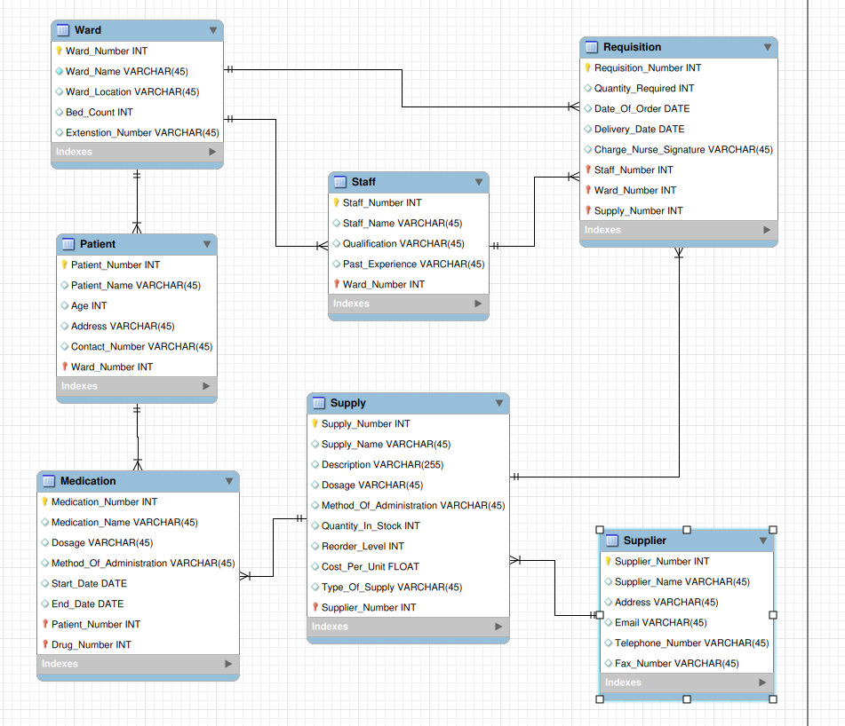

**Step 5.1**

-- Schema green_valley

-- -----------------------------------------------------

CREATE SCHEMA IF NOT EXISTS `green_valley` ;

USE `green_valley` ;

-- -----------------------------------------------------

-- Table `green_valley`.`Ward`

-- -----------------------------------------------------

CREATE TABLE IF NOT EXISTS `green_valley`.`Ward` (

`Ward_Number` INT NOT NULL,

`Ward_Name` VARCHAR(45) NOT NULL,

`Ward_Location` VARCHAR(45) NULL,

`Bed_Count` INT NULL,

`Extenstion_Number` VARCHAR(45) NULL,

PRIMARY KEY (`Ward_Number`),

UNIQUE INDEX `Ward_Number_UNIQUE` (`Ward_Number` ASC) VISIBLE)

ENGINE = InnoDB;

-- -----------------------------------------------------

-- Table `green_valley`.`Patient`

-- -----------------------------------------------------

CREATE TABLE IF NOT EXISTS `green_valley`.`Patient` (

`Patient_Number` INT NOT NULL,

`Patient_Name` VARCHAR(45) NULL,

`Age` INT NULL,

`Address` VARCHAR(45) NULL,

`Contact_Number` VARCHAR(45) NULL,

`Ward_Number` INT NOT NULL,

PRIMARY KEY (`Patient_Number`, `Ward_Number`),

UNIQUE INDEX `Patien_Number_UNIQUE` (`Patient_Number` ASC) VISIBLE,

INDEX `fk_Patient_Ward_idx` (`Ward_Number` ASC) VISIBLE,

CONSTRAINT `fk_Patient_Ward`

FOREIGN KEY (`Ward_Number`)

REFERENCES `green_valley`.`Ward` (`Ward_Number`)

ON DELETE NO ACTION

ON UPDATE NO ACTION)

ENGINE = InnoDB;

-- -----------------------------------------------------

-- Table `green_valley`.`Supplier`

-- -----------------------------------------------------

CREATE TABLE IF NOT EXISTS `green_valley`.`Supplier` (

`Supplier_Number` INT NOT NULL,

`Supplier_Name` VARCHAR(45) NULL,

`Address` VARCHAR(45) NULL,

`Email` VARCHAR(45) NULL,

`Telephone_Number` VARCHAR(45) NULL,

`Fax_Number` VARCHAR(45) NULL,

PRIMARY KEY (`Supplier_Number`),

UNIQUE INDEX `Supplier_Number_UNIQUE` (`Supplier_Number` ASC) VISIBLE)

ENGINE = InnoDB;

-- -----------------------------------------------------

-- Table `green_valley`.`Supply`

-- -----------------------------------------------------

CREATE TABLE IF NOT EXISTS `green_valley`.`Supply` (

`Supply_Number` INT NOT NULL,

`Supply_Name` VARCHAR(45) NULL,

`Description` VARCHAR(255) NULL,

`Dosage` VARCHAR(45) NULL,

`Method_Of_Administration` VARCHAR(45) NULL,

`Quantity_In_Stock` INT NULL,

`Reorder_Level` INT NULL,

`Cost_Per_Unit` FLOAT NULL,

`Type_Of_Supply` VARCHAR(45) NULL,

`Supplier_Number` INT NOT NULL,

PRIMARY KEY (`Supply_Number`, `Supplier_Number`),

UNIQUE INDEX `Drug_Number_UNIQUE` (`Supply_Number` ASC) VISIBLE,

INDEX `fk_Supply_Supplier1_idx` (`Supplier_Number` ASC) VISIBLE,

CONSTRAINT `fk_Supply_Supplier1`

FOREIGN KEY (`Supplier_Number`)

REFERENCES `green_valley`.`Supplier` (`Supplier_Number`)

ON DELETE NO ACTION

ON UPDATE NO ACTION)

ENGINE = InnoDB;

-- -----------------------------------------------------

-- Table `green_valley`.`Medication`

-- -----------------------------------------------------

CREATE TABLE IF NOT EXISTS `green_valley`.`Medication` (

`Medication_Number` INT NOT NULL,

`Medication_Name` VARCHAR(45) NULL,

`Dosage` VARCHAR(45) NULL,

`Method_Of_Administration` VARCHAR(45) NULL,

`Start_Date` DATE NULL,

`End_Date` DATE NULL,

`Patient_Number` INT NOT NULL,

`Drug_Number` INT NOT NULL,

PRIMARY KEY (`Medication_Number`, `Patient_Number`, `Drug_Number`),

UNIQUE INDEX `Medication_Number_UNIQUE` (`Medication_Number` ASC) VISIBLE,

INDEX `fk_Medication_Patient1_idx` (`Patient_Number` ASC) VISIBLE,

INDEX `fk_Medication_Pharmaceutical_Supply1_idx` (`Drug_Number` ASC) VISIBLE,

CONSTRAINT `fk_Medication_Patient1`

FOREIGN KEY (`Patient_Number`)

REFERENCES `green_valley`.`Patient` (`Patient_Number`)

ON DELETE NO ACTION

ON UPDATE NO ACTION,

CONSTRAINT `fk_Medication_Pharmaceutical_Supply1`

FOREIGN KEY (`Drug_Number`)

REFERENCES `green_valley`.`Supply` (`Supply_Number`)

ON DELETE NO ACTION

ON UPDATE NO ACTION)

ENGINE = InnoDB;

-- -----------------------------------------------------

-- Table `green_valley`.`Staff`

-- -----------------------------------------------------

CREATE TABLE IF NOT EXISTS `green_valley`.`Staff` (

`Staff_Number` INT NOT NULL,

`Staff_Name` VARCHAR(45) NULL,

`Qualification` VARCHAR(45) NULL,

`Past_Experience` VARCHAR(45) NULL,

`Ward_Number` INT NOT NULL,

PRIMARY KEY (`Staff_Number`, `Ward_Number`),

UNIQUE INDEX `Staff_Number_UNIQUE` (`Staff_Number` ASC) VISIBLE,

INDEX `fk_Staff_Ward1_idx` (`Ward_Number` ASC) VISIBLE,

CONSTRAINT `fk_Staff_Ward1`

FOREIGN KEY (`Ward_Number`)

REFERENCES `green_valley`.`Ward` (`Ward_Number`)

ON DELETE NO ACTION

ON UPDATE NO ACTION)

ENGINE = InnoDB;

-- -----------------------------------------------------

-- Table `green_valley`.`Requisition`

-- -----------------------------------------------------

CREATE TABLE IF NOT EXISTS `green_valley`.`Requisition` (

`Requisition_Number` INT NOT NULL,

`Quantity_Required` INT NULL,

`Date_Of_Order` DATE NULL,

`Delivery_Date` DATE NULL,

`Charge_Nurse_Signature` VARCHAR(45) NULL,

`Staff_Number` INT NOT NULL,

`Ward_Number` INT NOT NULL,

`Supply_Number` INT NOT NULL,

PRIMARY KEY (`Requisition_Number`, `Staff_Number`, `Ward_Number`, `Supply_Number`),

UNIQUE INDEX `Requisition_Number_UNIQUE` (`Requisition_Number` ASC) VISIBLE,

INDEX `fk_Requisition_Staff1_idx` (`Staff_Number` ASC) VISIBLE,

INDEX `fk_Requisition_Ward1_idx` (`Ward_Number` ASC) VISIBLE,

INDEX `fk_Requisition_Supply1_idx` (`Supply_Number` ASC) VISIBLE,

CONSTRAINT `fk_Requisition_Staff1`

FOREIGN KEY (`Staff_Number`)

REFERENCES `green_valley`.`Staff` (`Staff_Number`)

ON DELETE NO ACTION

ON UPDATE NO ACTION,

CONSTRAINT `fk_Requisition_Ward1`

FOREIGN KEY (`Ward_Number`)

REFERENCES `green_valley`.`Ward` (`Ward_Number`)

ON DELETE NO ACTION

ON UPDATE NO ACTION,

CONSTRAINT `fk_Requisition_Supply1`

FOREIGN KEY (`Supply_Number`)

REFERENCES `green_valley`.`Supply` (`Supply_Number`)

ON DELETE NO ACTION

ON UPDATE NO ACTION)

ENGINE = InnoDB;

SET SQL_MODE=@OLD_SQL_MODE;

SET FOREIGN_KEY_CHECKS=@OLD_FOREIGN_KEY_CHECKS;

SET UNIQUE_CHECKS=@OLD_UNIQUE_CHECKS;

**Step 5.2**

**Medication Table**

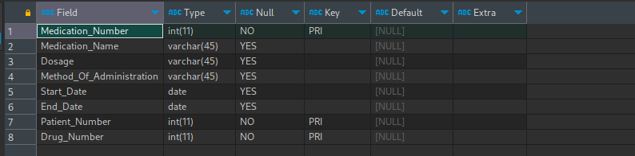

**Patient Table**

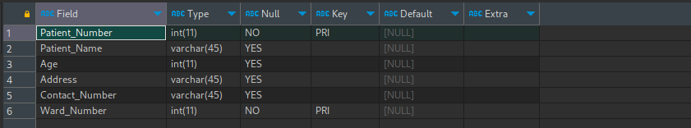

**Staff Table**

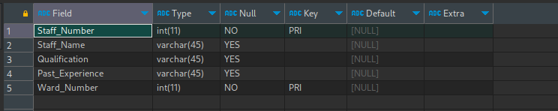

**Supplier Table**

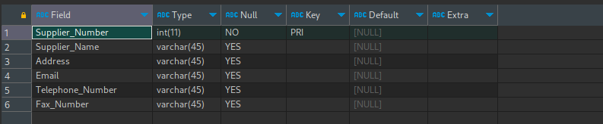

**Supply Table**

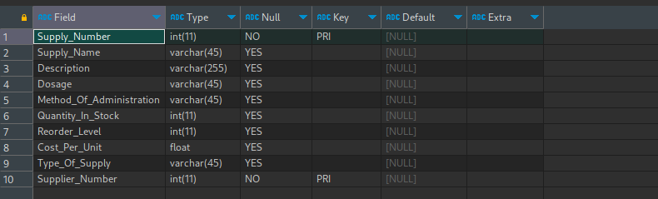

**Ward Table**

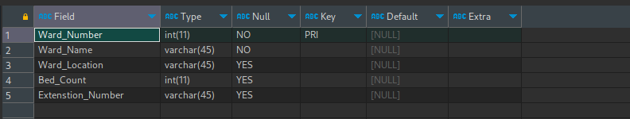

**Step 5.3**

INSERT INTO Ward (`Ward_Number`, `Ward_Name`, `Ward_Location`, `Bed_Count`, `Extenstion_Number`) VALUES

(1, 'Pediatrics', 'East Wing', 20, 'Ext-101'),

(2, 'Orthopedics', 'West Wing', 15, 'Ext-102'),

(3, 'Cardiology', 'North Wing', 30, 'Ext-103'),

(4, 'Neurology', 'South Wing', 25, 'Ext-104'),

(5, 'Oncology', 'West Wing', 18, 'Ext-105'),

(6, 'Gynecology', 'East Wing', 12, 'Ext-106'),

(7, 'Urology', 'North Wing', 10, 'Ext-107'),

(8, 'ENT', 'South Wing', 8, 'Ext-108'),

(9, 'Dermatology', 'West Wing', 14, 'Ext-109'),

(10, 'Psychiatry', 'East Wing', 16, 'Ext-110'),

(11, 'General Surgery', 'North Wing', 22, 'Ext-111'),

(12, 'Internal Medicine', 'South Wing', 25, 'Ext-112'),

(13, 'Nephrology', 'West Wing', 9, 'Ext-113'),

(14, 'Ophthalmology', 'East Wing', 10, 'Ext-114'),

(15, 'Pulmonology', 'North Wing', 12, 'Ext-115'),

(16, 'Rheumatology', 'South Wing', 7, 'Ext-116'),

(17, 'Endocrinology', 'West Wing', 11, 'Ext-117'),

(18, 'Hematology', 'East Wing', 8, 'Ext-118'),

(19, 'Gastroenterology', 'North Wing', 15, 'Ext-119'),

(20, 'Dentistry', 'South Wing', 6, 'Ext-120');

-------------------------

INSERT INTO Patient (`Patient_Number`, `Patient_Name`, `Age`, `Address`, `Contact_Number`, `Ward_Number`) VALUES

(1, 'John Doe', 35, '123 Main St', '555-123-4567', 3),

(2, 'Jane Smith', 45, '456 Oak Ave', '555-987-6543', 1),

(3, 'Michael Johnson', 28, '789 Elm Rd', '555-555-5555', 2),

(4, 'Emily Williams', 62, '321 Maple Ln', '555-222-3333', 4),

(5, 'William Brown', 50, '555 Pine St', '555-444-7890', 5),

(6, 'Olivia Lee', 19, '777 Birch Ave', '555-777-8888', 6),

(7, 'James Davis', 72, '888 Cedar Rd', '555-999-1111', 9),

(8, 'Sophia Garcia', 55, '999 Spruce Ln', '555-333-2222', 8),

(9, 'Liam Rodriguez', 42, '111 Willow St', '555-222-1111', 11),

(10, 'Emma Martinez', 30, '222 Palm Ave', '555-444-2222', 12),

(11, 'Noah Hernandez', 25, '333 Rose Rd', '555-666-5555', 14),

(12, 'Ava Lopez', 68, '444 Ivy Ave', '555-777-4444', 15),

(13, 'Sophia Brown', 37, '555 Vine St', '555-999-3333', 16),

(14, 'Michael Smith', 41, '666 Oak Ave', '555-111-7777', 18),

(15, 'Olivia Johnson', 29, '777 Elm Rd', '555-555-5555', 20),

(16, 'William Williams', 52, '888 Maple Ln', '555-222-8888', 19),

(17, 'Emily Davis', 48, '999 Pine St', '555-444-1111', 17),

(18, 'James Martinez', 33, '111 Birch Ave', '555-777-3333', 13),

(19, 'Sophia Rodriguez', 39, '222 Cedar Rd', '555-999-6666', 10),

(20, 'Ava Garcia', 61, '333 Spruce Ln', '555-333-4444', 7);

------------------------------

INSERT INTO Supplier (`Supplier_Number`, `Supplier_Name`, `Address`, `Email`, `Telephone_Number`, `Fax_Number`) VALUES

(1, 'ABC Medical Supplies', '123 Main St', 'abc@example.com', '555-123-4567', '555-987-6543'),

(2, 'XYZ Pharma', '456 Oak Ave', 'xyz@example.com', '555-222-3333', '555-444-7890'),

(3, 'MediCorp', '789 Elm Rd', 'medicorp@example.com', '555-555-5555', '555-777-8888'),

(4, 'Global Healthcare', '321 Maple Ln', 'globalhealth@example.com', '555-999-1111', '555-333-2222'),

(5, 'HealthPlus', '555 Pine St', 'healthplus@example.com', '555-222-1111', '555-444-2222'),

(6, 'PharmaLink', '777 Birch Ave', 'pharmalink@example.com', '555-666-5555', '555-777-4444'),

(7, 'MedEquip', '888 Cedar Rd', 'medequip@example.com', '555-999-3333', '555-111-7777'),

(8, 'Sunrise Medical', '999 Spruce Ln', 'sunrise@example.com', '555-555-5555', '555-222-8888'),

(9, 'Best Care Pharmaceuticals', '111 Willow St', 'bestcare@example.com', '555-444-1111', '555-444-1111'),

(10, 'MediSupply', '222 Palm Ave', 'medisupply@example.com', '555-777-7777', '555-999-9999'),

(11, 'HealthTech', '333 Rose Rd', 'healthtech@example.com', '555-333-3333', '555-111-1111'),

(12, 'PharmaWorld', '444 Ivy Ave', 'pharmaworld@example.com', '555-222-2222', '555-888-8888'),

(13, 'Vital Healthcare', '555 Vine St', 'vitalhealth@example.com', '555-666-6666', '555-333-3333'),

(14, 'MediLife', '666 Oak Ave', 'medilife@example.com', '555-999-9999', '555-666-6666'),

(15, 'Prime Medical Supplies', '777 Elm Rd', 'prime@example.com', '555-444-4444', '555-222-2222'),

(16, 'Allied Pharma', '888 Maple Ln', 'alliedpharma@example.com', '555-777-7777', '555-444-4444'),

(17, 'HealthFirst', '999 Pine St', 'healthfirst@example.com', '555-111-1111', '555-777-7777'),

(18, 'MediAid', '111 Birch Ave', 'mediaid@example.com', '555-888-8888', '555-999-9999'),

(19, 'PharmaDirect', '222 Cedar Rd', 'pharmadirect@example.com', '555-333-3333', '555-555-5555'),

(20, 'United Medical', '333 Spruce Ln', 'unitedmedical@example.com', '555-666-6666', '555-333-3333');

----------------------------

INSERT INTO Supply (`Supply_Number`, `Supply_Name`, `Description`, `Dosage`, `Method_Of_Administration`, `Quantity_In_Stock`, `Reorder_Level`, `Cost_Per_Unit`, `Type_Of_Supply`, `Supplier_Number`) VALUES

(1, 'Paracetamol', 'Pain reliever and fever reducer', '500mg', 'Oral', 1000, 100, 2.5, 'Tablet', 1),

(2, 'Ibuprofen', 'Nonsteroidal anti-inflammatory drug', '400mg', 'Oral', 800, 150, 3.0, 'Tablet', 2),

(3, 'Aspirin', 'Pain reliever and antiplatelet', '325mg', 'Oral', 1200, 200, 1.8, 'Tablet', 1),

(4, 'Amoxicillin', 'Antibiotic', '250mg', 'Oral', 500, 50, 4.2, 'Capsule', 3),

(5, 'Ciprofloxacin', 'Broad-spectrum antibiotic', '500mg', 'Oral', 300, 30, 6.7, 'Tablet', 2),

(6, 'Lisinopril', 'ACE inhibitor for hypertension', '10mg', 'Oral', 400, 40, 2.9, 'Tablet', 4),

(7, 'Metformin', 'Antidiabetic medication', '500mg', 'Oral', 700, 70, 1.5, 'Tablet', 5),

(8, 'Loratadine', 'Antihistamine', '10mg', 'Oral', 600, 60, 3.8, 'Tablet', 6),

(9, 'Fluoxetine', 'Selective serotonin reuptake inhibitor', '20mg', 'Oral', 250, 25, 5.1, 'Capsule', 7),

(10, 'Simvastatin', 'HMG-CoA reductase inhibitor', '40mg', 'Oral', 300, 30, 4.9, 'Tablet', 8),

(11, 'Albuterol', 'Bronchodilator', '2mg', 'Inhalation', 200, 20, 10.5, 'Inhaler', 9),

(12, 'Insulin Lispro', 'Rapid-acting insulin', '100 units/mL', 'Subcutaneous', 150, 15, 12.2, 'Vial', 10),

(13, 'Omeprazole', 'Proton pump inhibitor', '20mg', 'Oral', 400, 40, 3.7, 'Capsule', 12),

(14, 'Atorvastatin', 'HMG-CoA reductase inhibitor', '20mg', 'Oral', 500, 50, 6.0, 'Tablet', 11),

(15, 'Prednisone', 'Corticosteroid', '5mg', 'Oral', 300, 30, 2.4, 'Tablet', 14),

(16, 'Escitalopram', 'Selective serotonin reuptake inhibitor', '10mg', 'Oral', 200, 20, 4.8, 'Tablet', 13),

(17, 'Warfarin', 'Anticoagulant', '5mg', 'Oral', 600, 60, 1.9, 'Tablet', 17),

(18, 'Metoprolol', 'Beta-blocker for hypertension', '25mg', 'Oral', 450, 45, 2.3, 'Tablet', 15),

(19, 'Losartan', 'Angiotensin II receptor blocker', '50mg', 'Oral', 350, 35, 3.5, 'Tablet', 18),

(20, 'Hydrochlorothiazide', 'Diuretic', '12.5mg', 'Oral', 500, 50, 2.7, 'Tablet', 19);

----------------------------

INSERT INTO Medication (`Medication_Number`, `Medication_Name`, `Dosage`, `Method_Of_Administration`, `Start_Date`, `End_Date`, `Patient_Number`, `Drug_Number`) VALUES

(1, 'Pain Relief', '500mg', 'Oral', '2023-07-01', '2023-07-10', 1, 1),

(2, 'Fever Reducer', '400mg', 'Oral', '2023-07-03', '2023-07-08', 2, 2),

(3, 'Antibiotic', '250mg', 'Oral', '2023-07-05', '2023-07-15', 3, 4),

(4, 'Allergy Relief', '10mg', 'Oral', '2023-07-10', '2023-07-20', 4, 8),

(5, 'Anti-inflammatory', '20mg', 'Oral', '2023-07-12', '2023-07-25', 5, 7),

(6, 'Asthma Control', '2mg', 'Inhalation', '2023-07-15', '2023-07-30', 6, 11),

(7, 'Antidiabetic', '500mg', 'Oral', '2023-07-20', '2023-08-05', 7, 12),

(8, 'Antidepressant', '20mg', 'Oral', '2023-07-22', '2023-08-15', 8, 16),

(9, 'Blood Pressure Control', '10mg', 'Oral', '2023-07-25', '2023-08-10', 9, 6),

(10, 'Cholesterol Lowering', '40mg', 'Oral', '2023-07-28', '2023-08-18', 10, 10),

(11, 'Antiplatelet', '325mg', 'Oral', '2023-08-01', '2023-08-20', 11, 3),

(12, 'Anticoagulant', '5mg', 'Oral', '2023-08-05', '2023-08-25', 12, 17),

(13, 'Bronchodilator', '2mg', 'Inhalation', '2023-08-10', '2023-08-28', 13, 11),

(14, 'Insulin Therapy', '100 units/mL', 'Subcutaneous', '2023-08-15', '2023-09-05', 14, 12),

(15, 'Heart Medication', '25mg', 'Oral', '2023-08-20', '2023-09-08', 15, 18),

(16, 'Diuretic', '12.5mg', 'Oral', '2023-08-25', '2023-09-10', 16, 20),

(17, 'Pain Relief', '500mg', 'Oral', '2023-08-28', '2023-09-15', 17, 1),

(18, 'Antibiotic', '500mg', 'Oral', '2023-09-01', '2023-09-18', 18, 5),

(19, 'Anti-inflammatory', '20mg', 'Oral', '2023-09-05', '2023-09-20', 19, 7),

(20, 'Antidepressant', '10mg', 'Oral', '2023-09-10', '2023-09-25', 20, 16);

-----------------------------------

INSERT INTO Staff (`Staff_Number`, `Staff_Name`, `Qualification`, `Past_Experience`, `Ward_Number`) VALUES

(1, 'John Smith', 'Registered Nurse', '5 years at ABC Hospital', 1),

(2, 'Emily Johnson', 'Licensed Practical Nurse', '3 years at XYZ Clinic', 2),

(3, 'Michael Williams', 'Medical Doctor', '10 years at City Hospital', 3),

(4, 'Sophia Brown', 'Certified Nursing Assistant', '2 years at Community Care Center', 4),

(5, 'James Davis', 'Medical Technologist', '7 years at Regional Medical Center', 5),

(6, 'Olivia Garcia', 'Physician Assistant', '4 years at HealthPlus Clinic', 6),

(7, 'William Martinez', 'Pharmacist', '6 years at MediCorp Pharmacy', 7),

(8, 'Emma Rodriguez', 'Physical Therapist', '9 years at Sports Rehab Center', 8),

(9, 'Liam Hernandez', 'Occupational Therapist', '5 years at Senior Care Facility', 9),

(10, 'Ava Lopez', 'Speech-Language Pathologist', '3 years at Speech Center', 10),

(11, 'Noah Rivera', 'Medical Doctor', '8 years at County Hospital', 11),

(12, 'Isabella Turner', 'Registered Nurse', '6 years at Medical Center', 12),

(13, 'Mason Mitchell', 'Licensed Practical Nurse', '4 years at Home Healthcare Agency', 13),

(14, 'Sophia Phillips', 'Certified Nursing Assistant', '2 years at Elderly Care Home', 14),

(15, 'Alexander Campbell', 'Medical Technologist', '5 years at Diagnostic Lab', 15),

(16, 'Mia Scott', 'Physician Assistant', '3 years at Family Practice Clinic', 16),

(17, 'Ethan Adams', 'Pharmacist', '7 years at HealthMart Pharmacy', 17),

(18, 'Abigail Hernandez', 'Physical Therapist', '4 years at Sports Medicine Center', 18),

(19, 'Jayden Wood', 'Occupational Therapist', '6 years at Rehabilitation Hospital', 19),

(20, 'Ella Foster', 'Speech-Language Pathologist', '5 years at Language Development Center', 20);

-------------------------

INSERT INTO `green_valley`.`Requisition` (`Requisition_Number`, `Quantity_Required`, `Date_Of_Order`, `Delivery_Date`, `Charge_Nurse_Signature`, `Staff_Number`, `Ward_Number`, `Supply_Number`) VALUES

(1, 50, '2023-07-01', '2023-07-05', 'CN-Sign-001', 1, 1, 1),

(2, 30, '2023-07-02', '2023-07-06', 'CN-Sign-002', 2, 2, 2),

(3, 40, '2023-07-03', '2023-07-07', 'CN-Sign-003', 3, 3, 3),

(4, 25, '2023-07-04', '2023-07-08', 'CN-Sign-004', 4, 4, 4),

(5, 60, '2023-07-05', '2023-07-09', 'CN-Sign-005', 5, 5, 5),

(6, 35, '2023-07-06', '2023-07-10', 'CN-Sign-006', 6, 6, 6),

(7, 20, '2023-07-07', '2023-07-11', 'CN-Sign-007', 7, 7, 7),

(8, 45, '2023-07-08', '2023-07-12', 'CN-Sign-008', 8, 8, 8),

(9, 55, '2023-07-09', '2023-07-13', 'CN-Sign-009', 9, 9, 9),

(10, 70, '2023-07-10', '2023-07-14', 'CN-Sign-010', 10, 10, 10),

(11, 28, '2023-07-11', '2023-07-15', 'CN-Sign-011', 11, 11, 11),

(12, 38, '2023-07-12', '2023-07-16', 'CN-Sign-012', 12, 12, 12),

(13, 42, '2023-07-13', '2023-07-17', 'CN-Sign-013', 13, 13, 13),

(14, 32, '2023-07-14', '2023-07-18', 'CN-Sign-014', 14, 14, 14),

(15, 48, '2023-07-15', '2023-07-19', 'CN-Sign-015', 15, 15, 15),

(16, 52, '2023-07-16', '2023-07-20', 'CN-Sign-016', 16, 16, 16),

(17, 18, '2023-07-17', '2023-07-21', 'CN-Sign-017', 17, 17, 17),

(18, 63, '2023-07-18', '2023-07-22', 'CN-Sign-018', 18, 18, 18),

(19, 24, '2023-07-19', '2023-07-23', 'CN-Sign-019', 19, 19, 19),

(20, 36, '2023-07-20', '2023-07-24', 'CN-Sign-020', 20, 20, 20);

5.4

* **Request: Find the name of the staff who is in ward 2 and taking care of patient with ID 3**

**SQL**

SELECT S.Staff_Number, S.Staff_Name, P.Patient_Number, P.Patient_Name, P.Ward_Number FROM Staff AS S INNER JOIN Patient AS P ON S.Ward_Number = P.Ward_Number WHERE P.Patient_Number = 3 AND S.Ward_Number = 2;

**Screenshot**

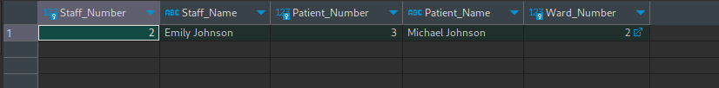

* **Request: Find the staffs who are assigned to Ward 6**

**SQL**

SELECT S.Staff_Number, S.Staff_Name, S.Qualification, S.Past_Experience, W.Ward_Number, W.Ward_Name, W.Ward_Location FROM Staff AS S INNER JOIN Ward AS W ON S.Ward_Number = W.Ward_Number WHERE S.Ward_Number = 6;

**Screenshot**



* **Request: Find all staff whose name starts with “A”**

**SQL**

SELECT * FROM Staff AS S WHERE S.Staff_Name LIKE 'A%';

**Screenshot**

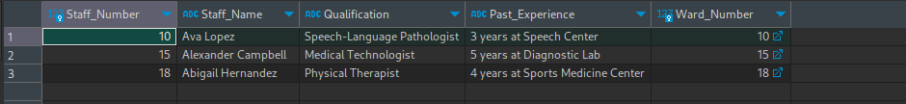

* **Request: Find all supplies that need to be reordered if the reorder level is less than 30**

**SQL**

SELECT * FROM Supply AS S WHERE S.Reorder_Level < 30;

**Screenshot**



* **Request: Find all patients who have been given the “Pain Relief”**

**SQL**

SELECT P.Patient_Number, P.Patient_Name, P.Address, M.Dosage, M.Method_Of_Administration, M.Start_Date, M.End_Date FROM Patient AS P INNER JOIN Medication AS M ON P.Patient_Number = M.Patient_Number WHERE M.Medication_Name = "Pain Relief";

**Screenshot**

